**How to Configure DHCP Server on CentOS/RHEL 7/6/5**

* DHCP ([Dynamic Host Configuration Protocol](https://tecadmin.net/what-is-dhcp-server/)) is a network protocol used for assigning IP address to network clients dynamically from a predefined IP pool
* It is useful for LAN network, but not generally used for production servers

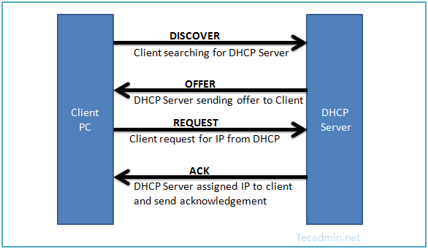

1. **Install dhcp package**

* Yum install dhcp

**2.Update /etc/sysconfig/dhcpd file.**

-> Firstly we need to set ethernet interface name

-> Add DHCPARGS=eth1

**3.Configure DHCP server**

-> DHCP create an empty configuration file in /etc/dhcp/dhcpd.conf

-> Dhcp provides sample file at /usr/share/doc/dhcp*/dhcpd.conf.example

-> So copy this file content into main conf file

Eg. cp /usr/share/doc/dhcp-4.1.1/dhcpd.conf.sample /etc/dhcp/dhcpd.conf

**3.1 Parameter Configuration**

-> configure the basic option which is common to support all network

Eg.

option domain-name "tecadmin.net";

option domain-name-servers ns1.tecadmin.net, ns2.tecadmin.net;

default-lease-time 600;

max-lease-time 7200;

authoritative;

log-facility local7;

**3.2 IP subnet Declaration**

-> Edit DHCP configuration file and update subnet details as per your network

Eg .

subnet 192.168.1.0 netmask 255.255.255.0 {

option routers 192.168.1.254;

option subnet-mask 255.255.255.0;

option domain-search "tecadmin.net";

option domain-name-servers 192.168.1.1;

option time-offset -18000; # Eastern Standard Time

range 192.168.1.10 192.168.1.100;

}

**3.3 Assign Static IP Address to Host**

-> host station1 {

option host-name "station1.example.com";

hardware ethernet 00:11:1A:2B:3C:AB;

fixed-address 192.168.1.100;

}

**4.Start DHCP Server**

* systemctl start dhcp

**5. Set up Client System**

-> At this stage we have a running dhcp server which is ready for accepting requests and assign them a proper ip. but to verify I have another CentOS machine running on same LAN. Now login to that client machine and edit Ethernet configuration file.

vim /etc/sysconfig/network-scripts/ifcfg-eth1

DEVICE=eth1

BOOTPROTO=dhcp

TYPE=Ethernet

ONBOOT=yes

Make sure **BOOTPROTO** is set to **dhcp**.

And start network services